CodeWarrior Debugger/Simulator Aid

**Homework 3 Sample Program**

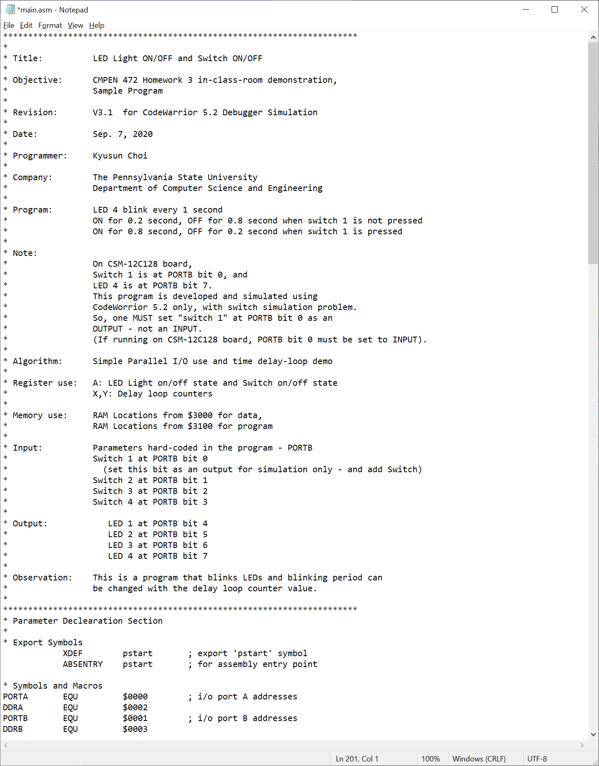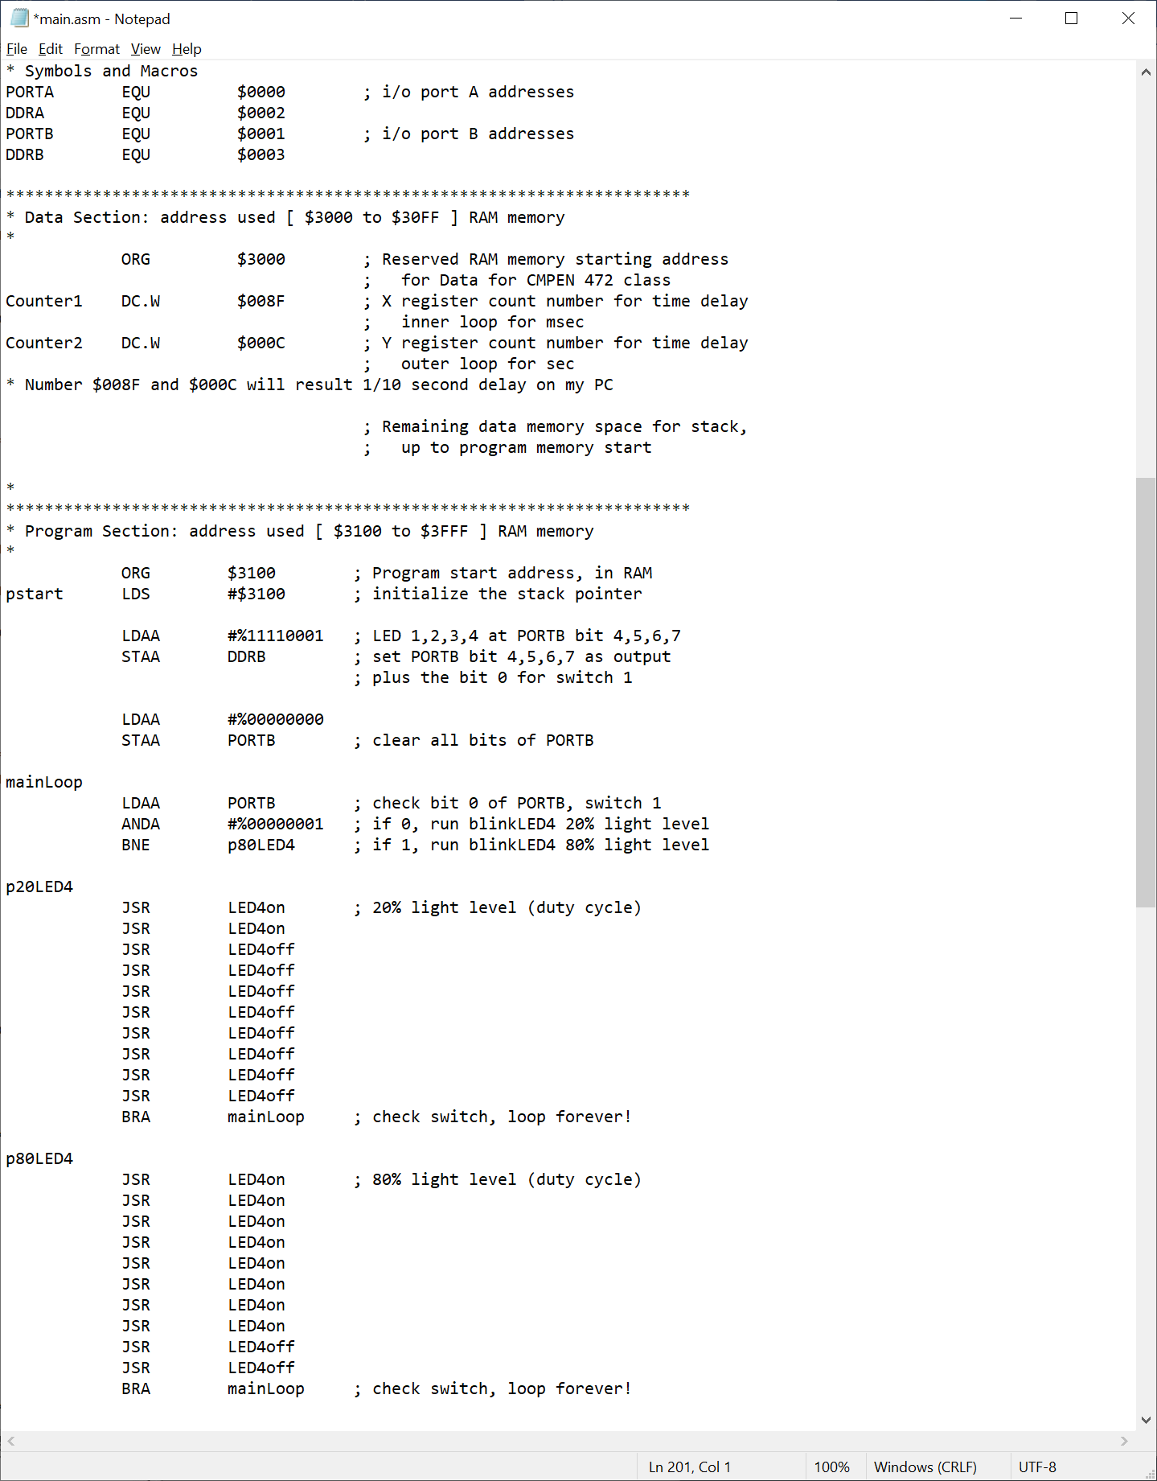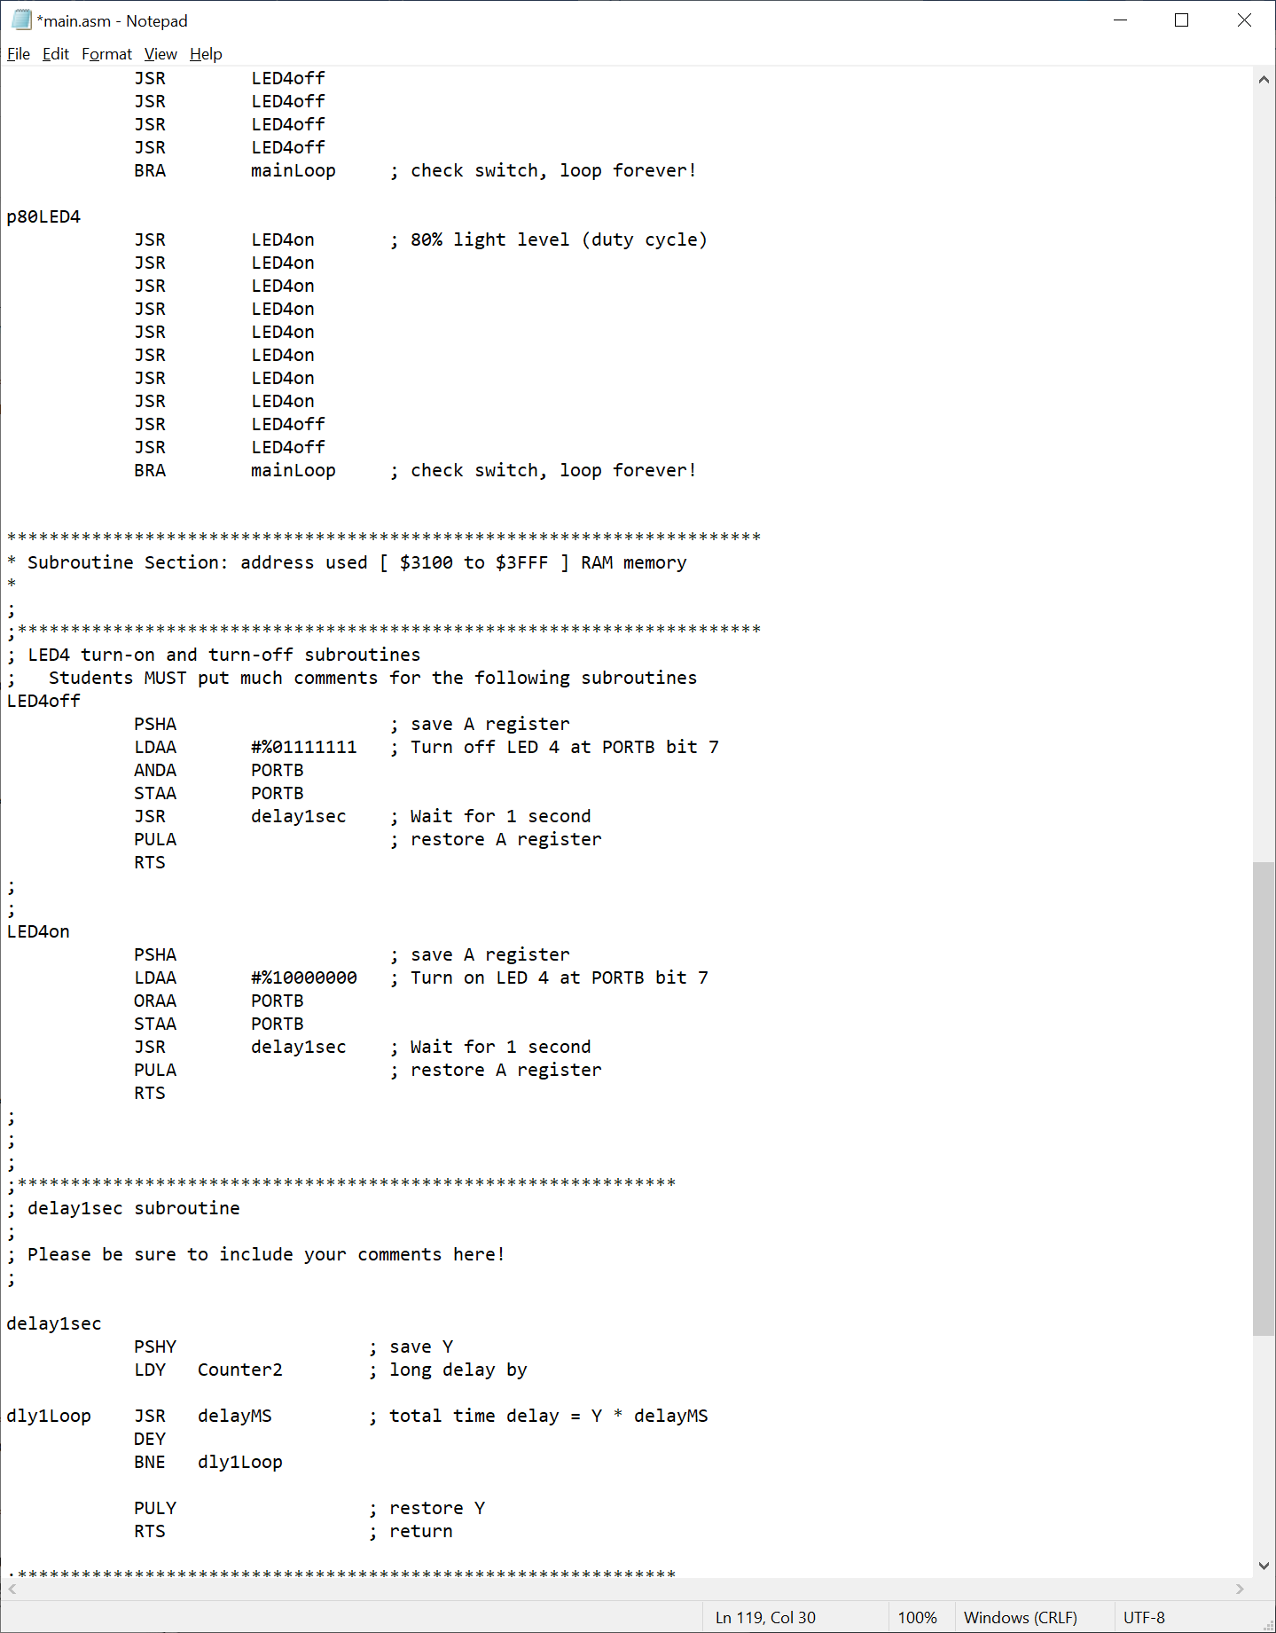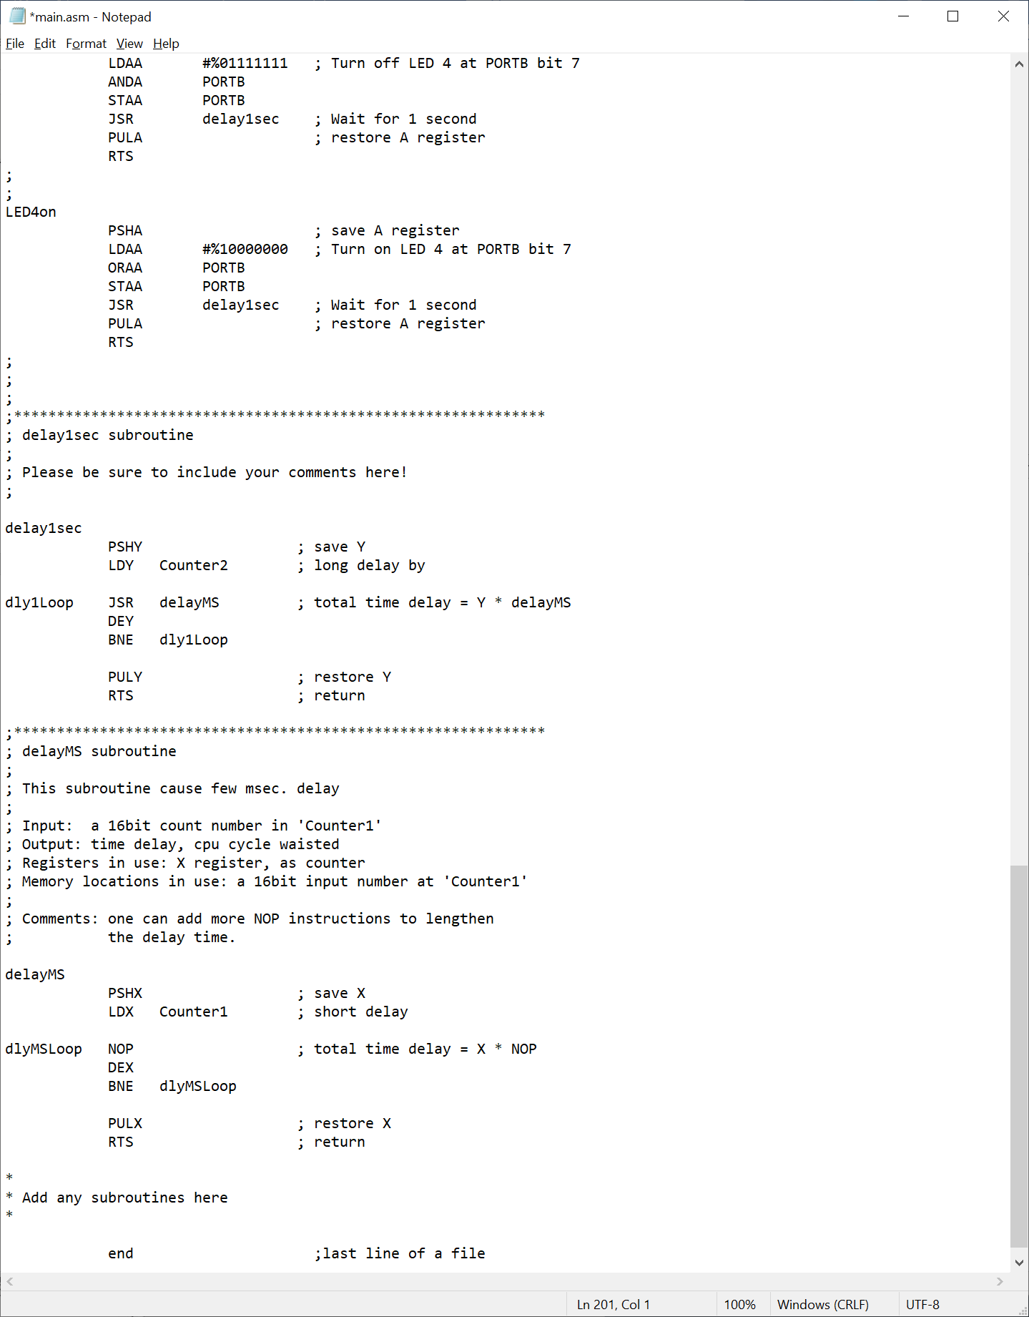

Start CodeWarrior Debugger/Simulator

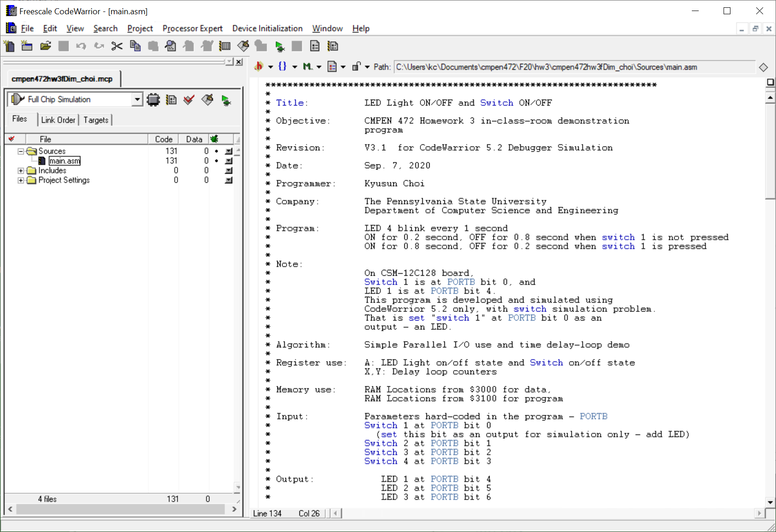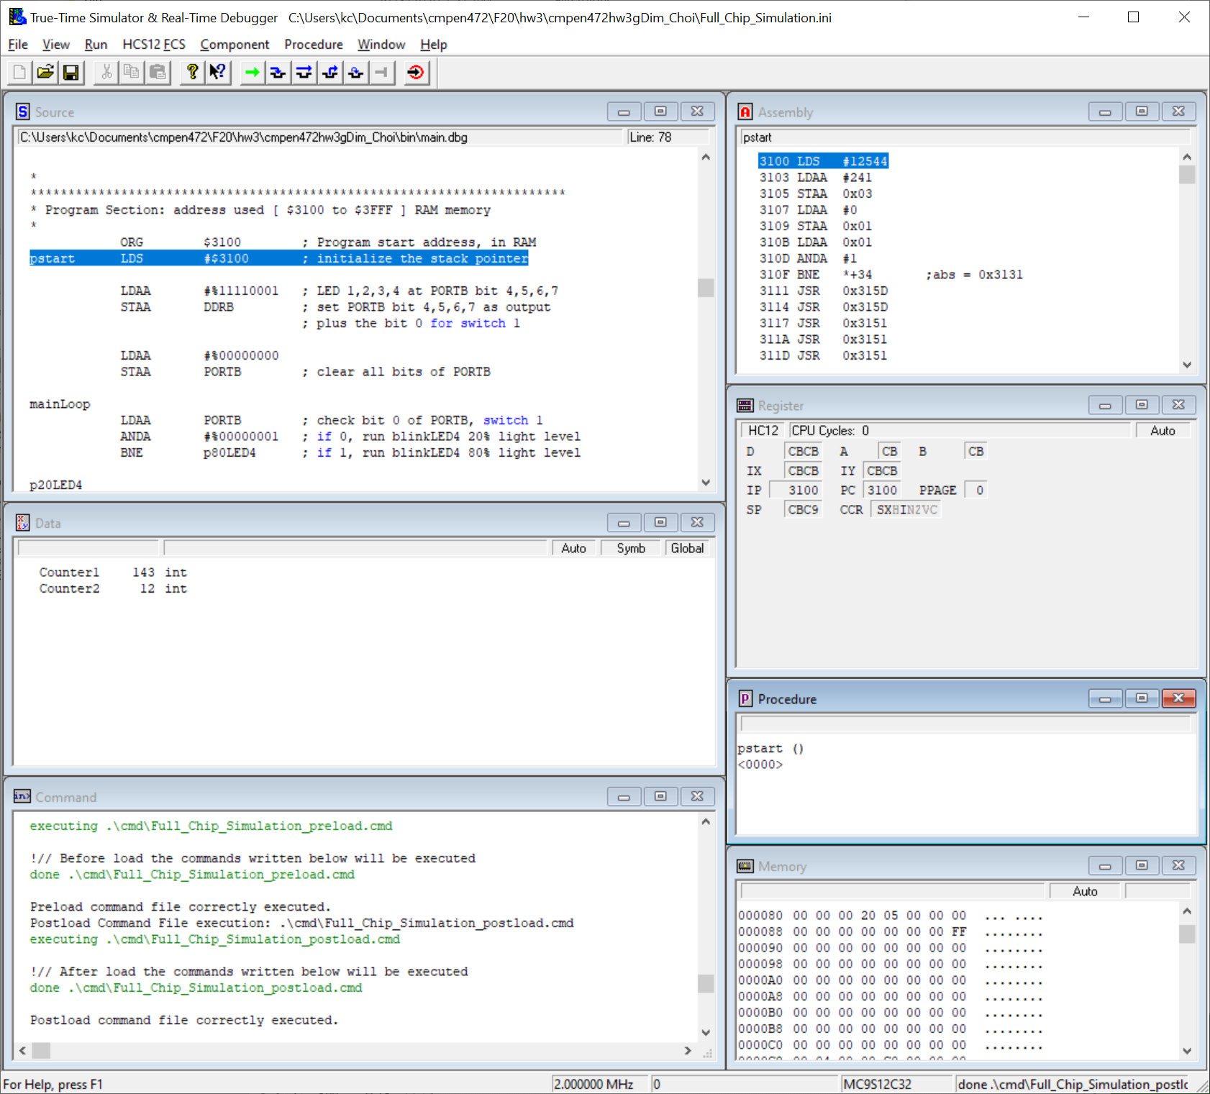

Click HC12FCS, and select “Clock Frequency . . . . ”

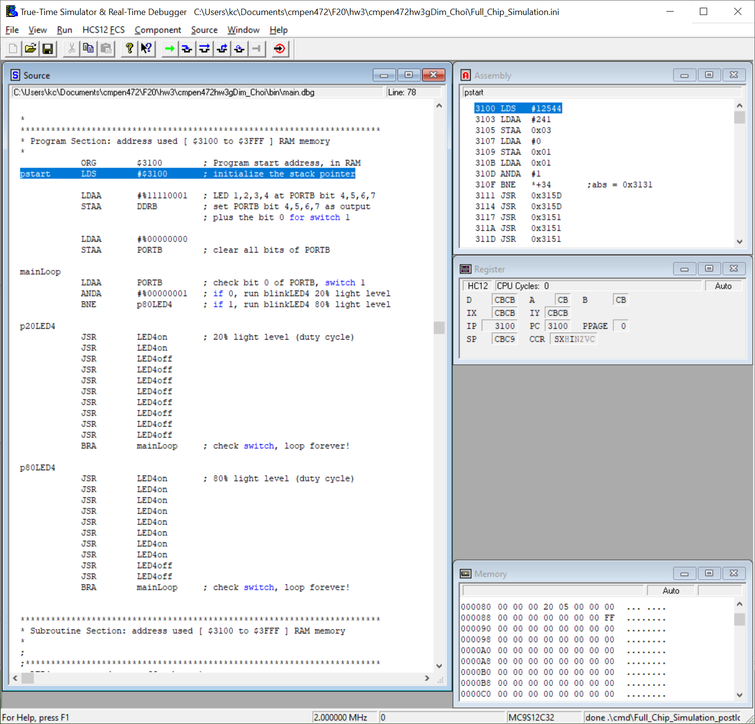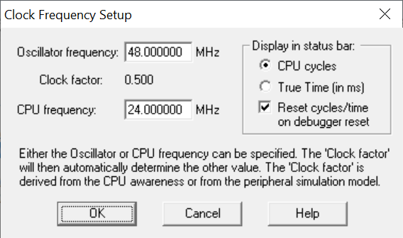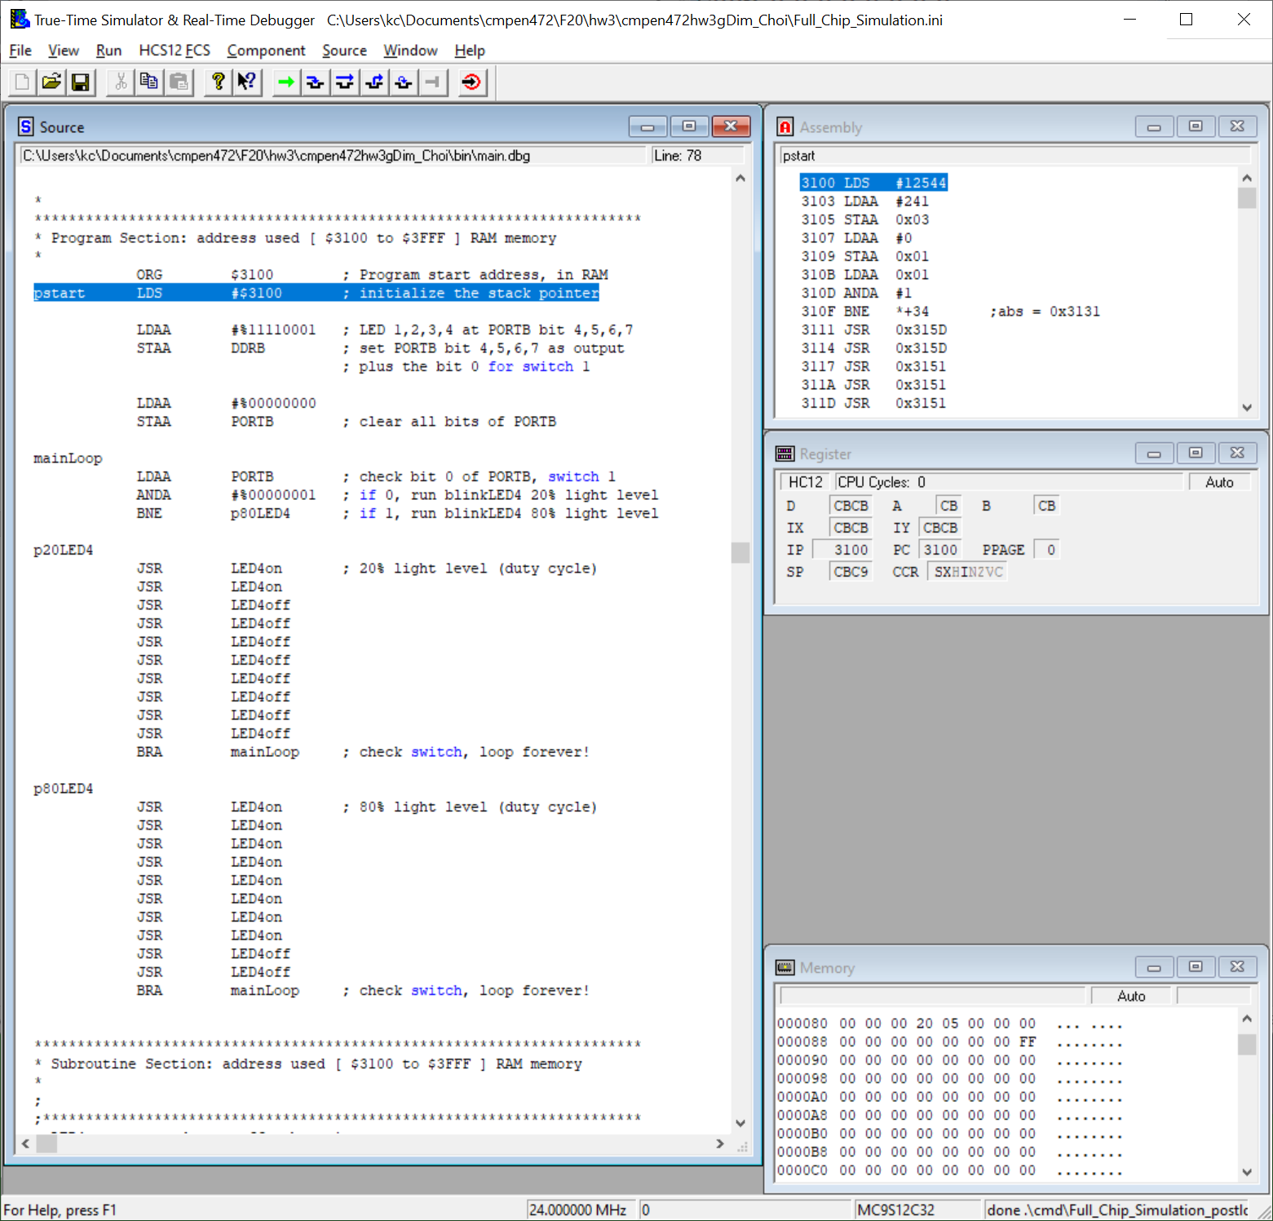

Display machine code on Assembly window: right click Assembly window and select “Display”, and then select “Code”.

Also display memory location $3000 on the Memory window: right click Memory window and select “Address”. Then type “3000” and click “OK”.

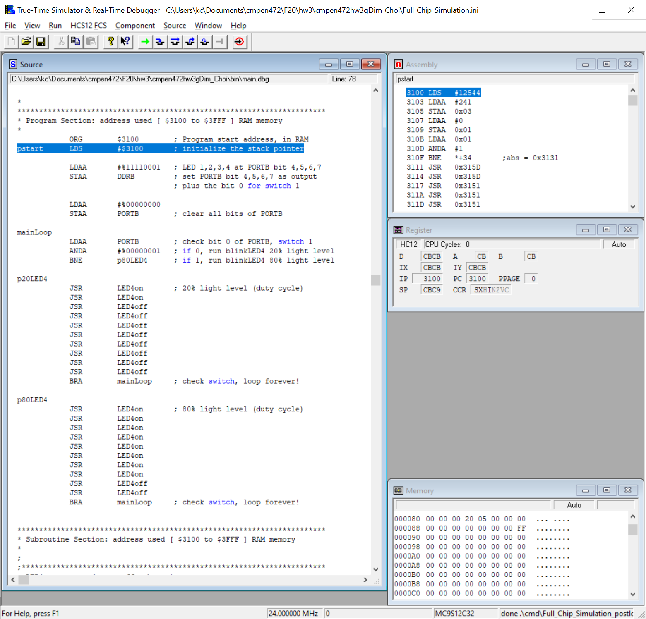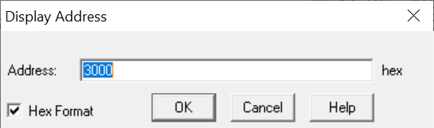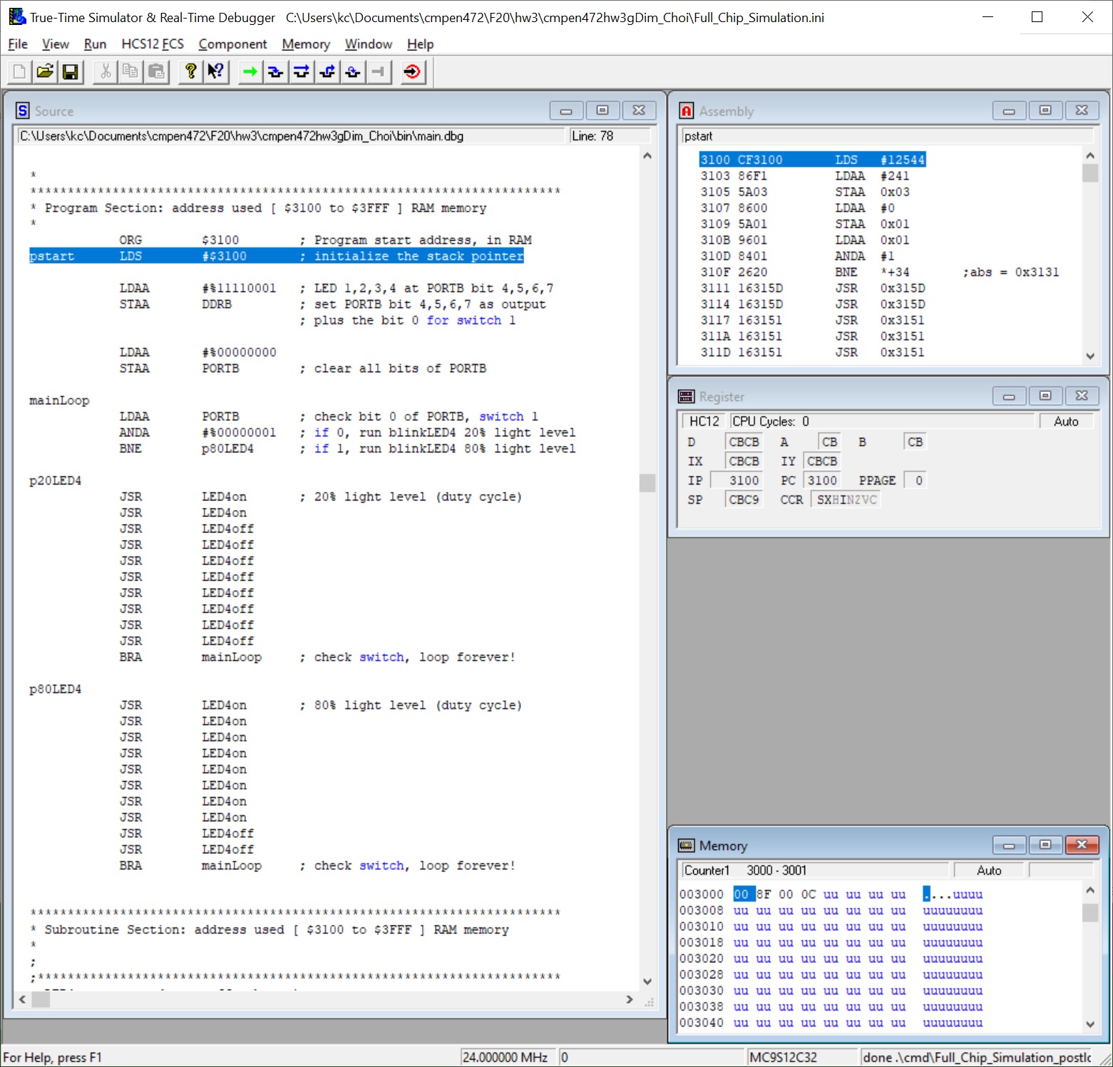

Add Component, Open . . . . Then select “Visualization . . .”

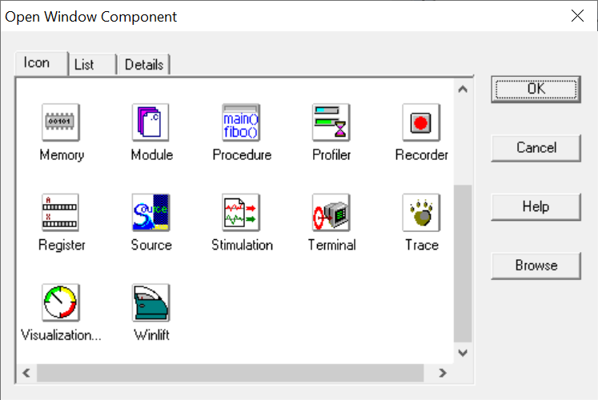

Right click on the Visualization Tool, and then select “Properties”.

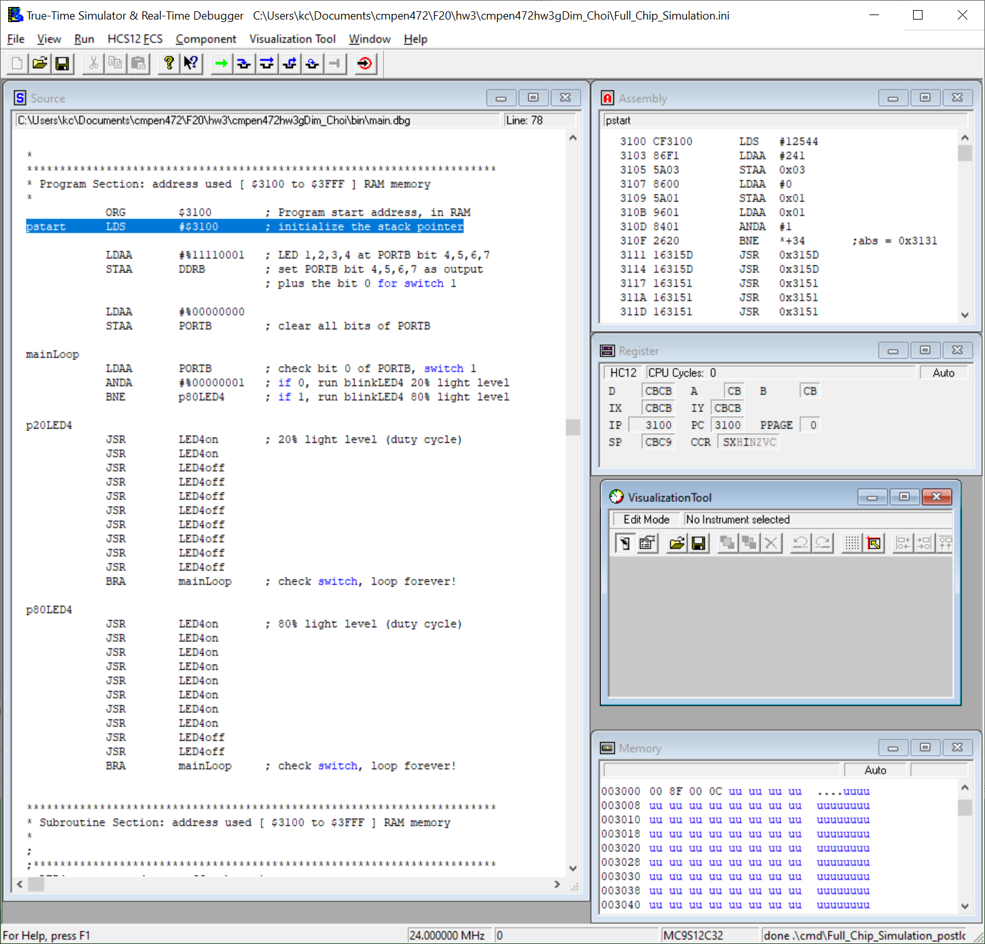

Enter “1” for Cycle Refresh Count.

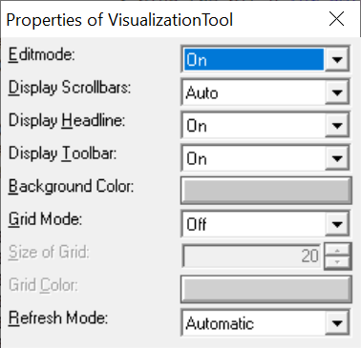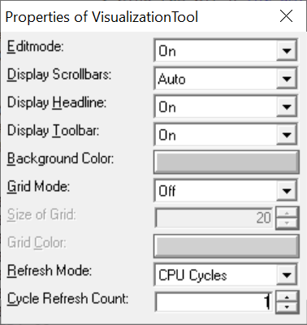

Right click on the Visualization Tool, and then select “Add New Instrument”. Then select “LED”.

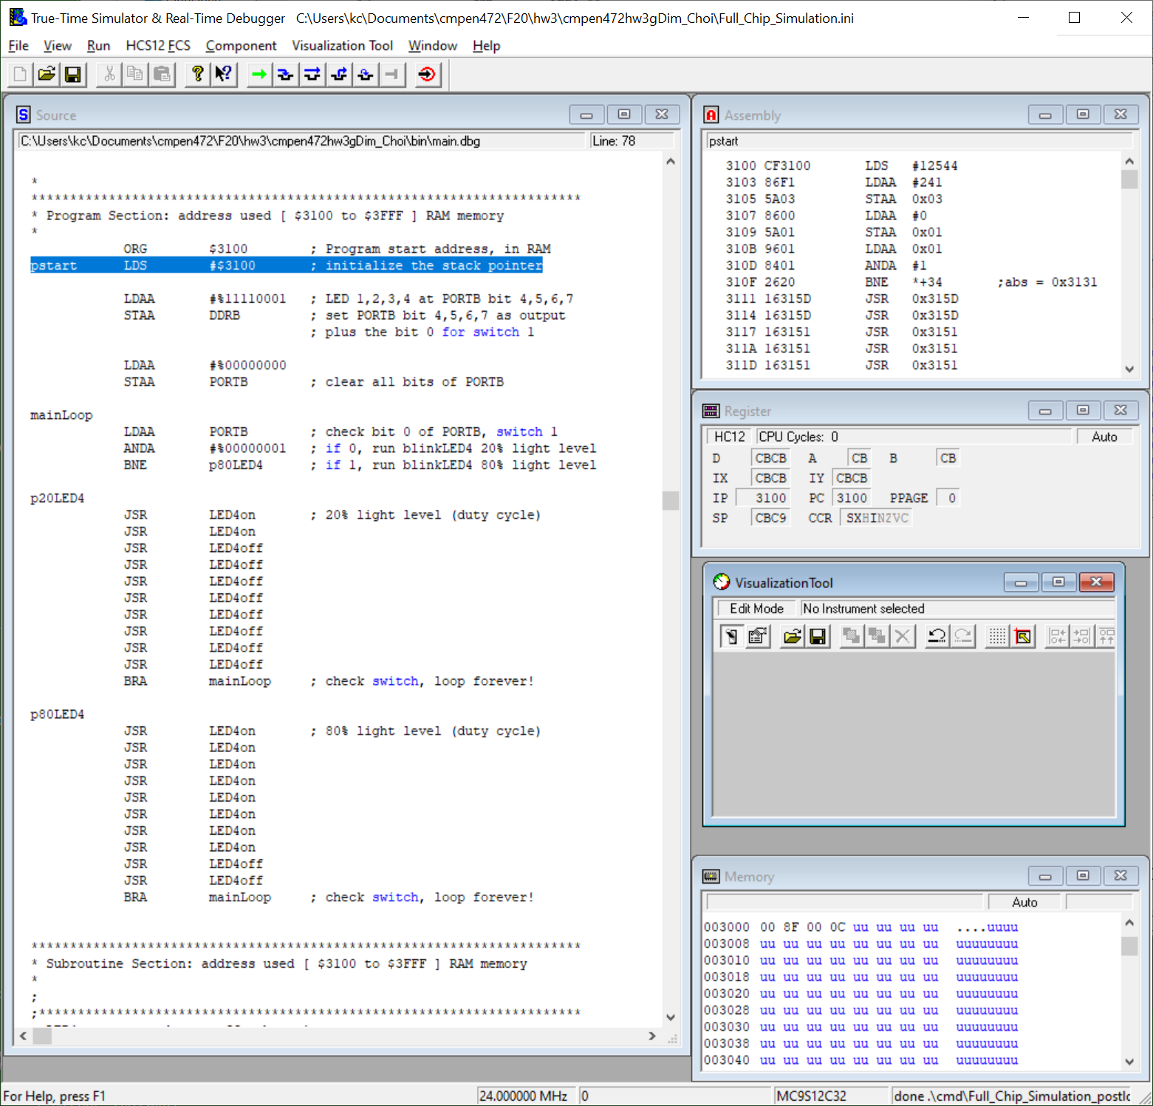

Right click on LED, select “Properties”, then enter “1” for “Port to Display:” and select “7” for “Bitnumber to Display:”.

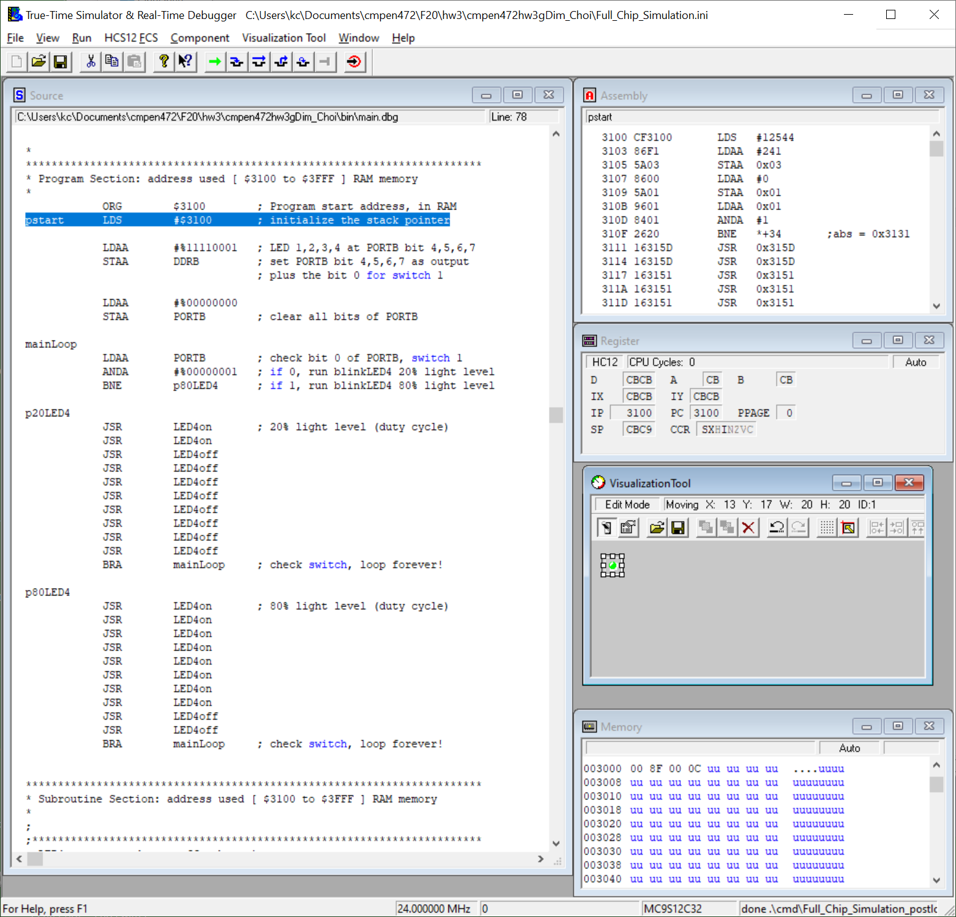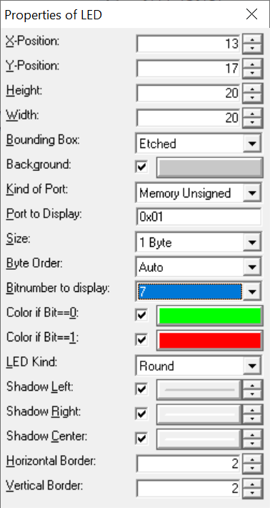

In a similar way, add LED 1, 2, and 3. That is, connect LED 1, 2, 3, and 4 to PORTB bit 4, 5, 6, and 7, respectively.

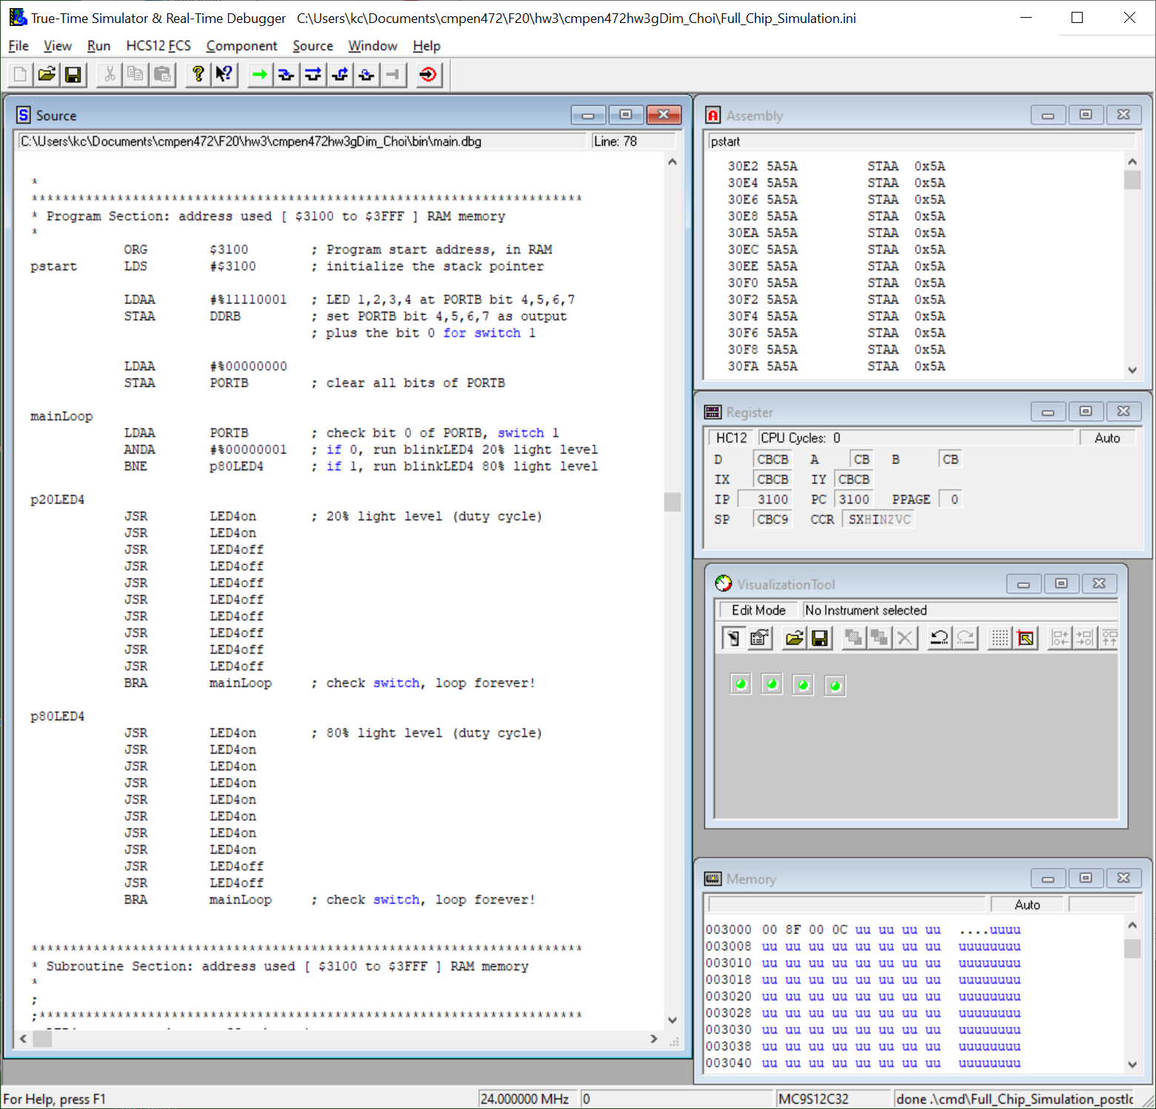

Right click on the Visualization Tool, and then select “Add New Instrument”. Then select “DIL Switch”.

Be sure to connect the DIL Switch to PORTB through their “properties”. (Please see Homework 2 sample program.)

Now change your Visualization Tool from “Edit Mode” to “Display Mode”, by right clicking the Visualization Tool and select the checked “Edit Mode”. The DIL Switch at PORTB will not work on “Edit Mode”, they work only on “Display Mode”.

Now the Debugger/Simulator is ready to simulate Homework 3 Sample program and you want to SAVE the setting.

Click on the “File” menu and select the “Save Configuration”.

Now run your program and observe LED 4 blinking.

While the program is running, click the Switch 1 in the Visualization Tool (DIL Switch bit 0). And observe the LED 4 blinking duty cycle, changing from 20% to 80%.

Now you can modify the Homework 3 Sample program to finish the Homework 3 program’s full specification.